Cade Echevary

Dr. Muthukumar

CPE403

December 11, 2020

CPE403 – Advanced Embedded Systems

# Design Assignment #4

DO NOT REMOVE THIS PAGE DURING SUBMISSION:

Name: Cade Echevary

Email:echevary@unlv.nevada.edu

Github Repository link (root): https://github.com/echevary/MicroController_proj

Youtube Playlist link (root): <https://www.youtube.com/playlist?list=PLx8r8972rBxGc7qQazP1uhUSINSNA5rNC>

Youtube Link: https://www.youtube.com/watch?v=xDgviZoGh4I&list=PLx8r8972rBxGc7qQazP1uhUSINSNA5rNC&index=6

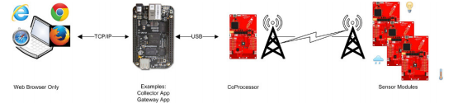TI 15.4-Stack Linux SDK with CC1352 and BBB

Problem Statement:

Our goal was to use the TI 15.4-Stack Linux SDK to create a star topology network with the BBB and two CC135x launchpads. We needed to use the lpstk to have one act as a sensor launchpad and the cc1352 as a co-processor for the BBB. The BBB would act as the embedded host.

The sensor used was the Si7021 temperature and humidity sensor.

There wasn’t much code that needed to be edited. And if it was edited it was things that the project directions told you to do so ill just submit the files.

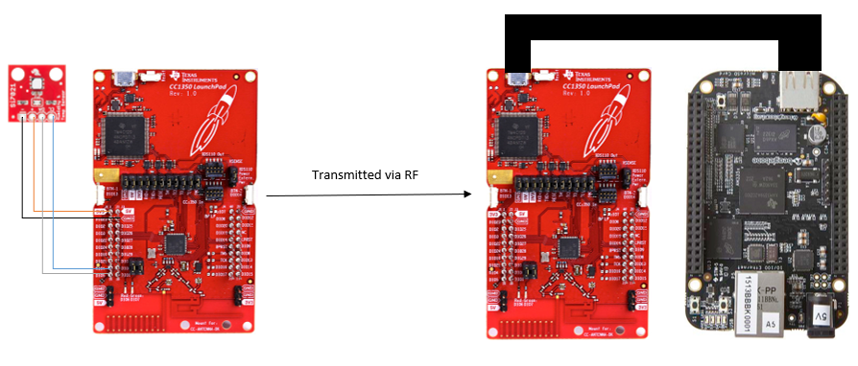Diagram

pre-requisites:

Components used:

* CC1352 – co-processor
* LPSTk used as sensor
* BeagleBone Black – Used as embedded host to run web application to display sensor data

Software used:

* UniFlash- used to flash the CC1350s to the correct configurations
* Code Composer Studio – The Sensor launchpad was programed in CCS
* Putty – Used to verify BBB was booted properly and to check value being sent
* Ubuntu VM – Used to set up the BBB

implementation details:

Implementing Si7021 to sensor node with I2C:

1. The first step was to flash the CC1352 Board with the hex file

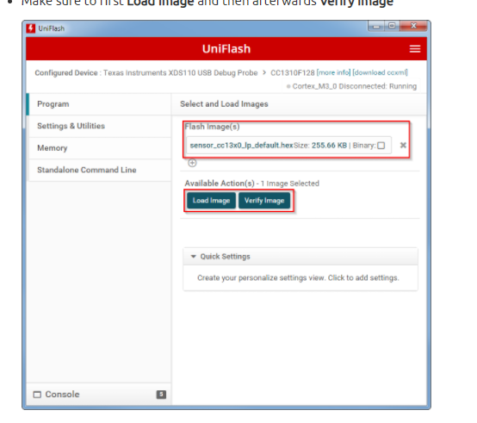

2. The next step was to copy our bbb prebuilt tar.gz files into the beaglebone

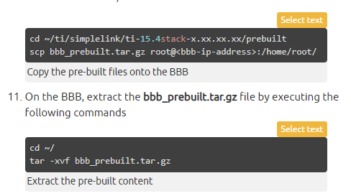

3. After that I needed to run the gateway

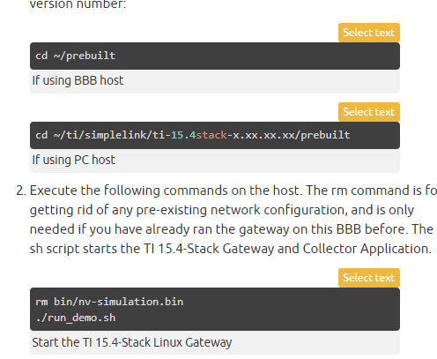

4. Then we extracted the data from the sensor and sent it to the co-processor:and this gives you your data through the gateway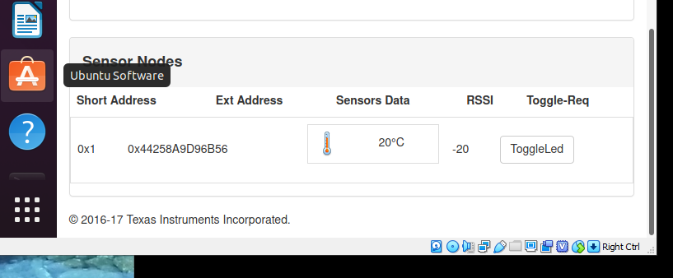

outcomes, results and conclusions:

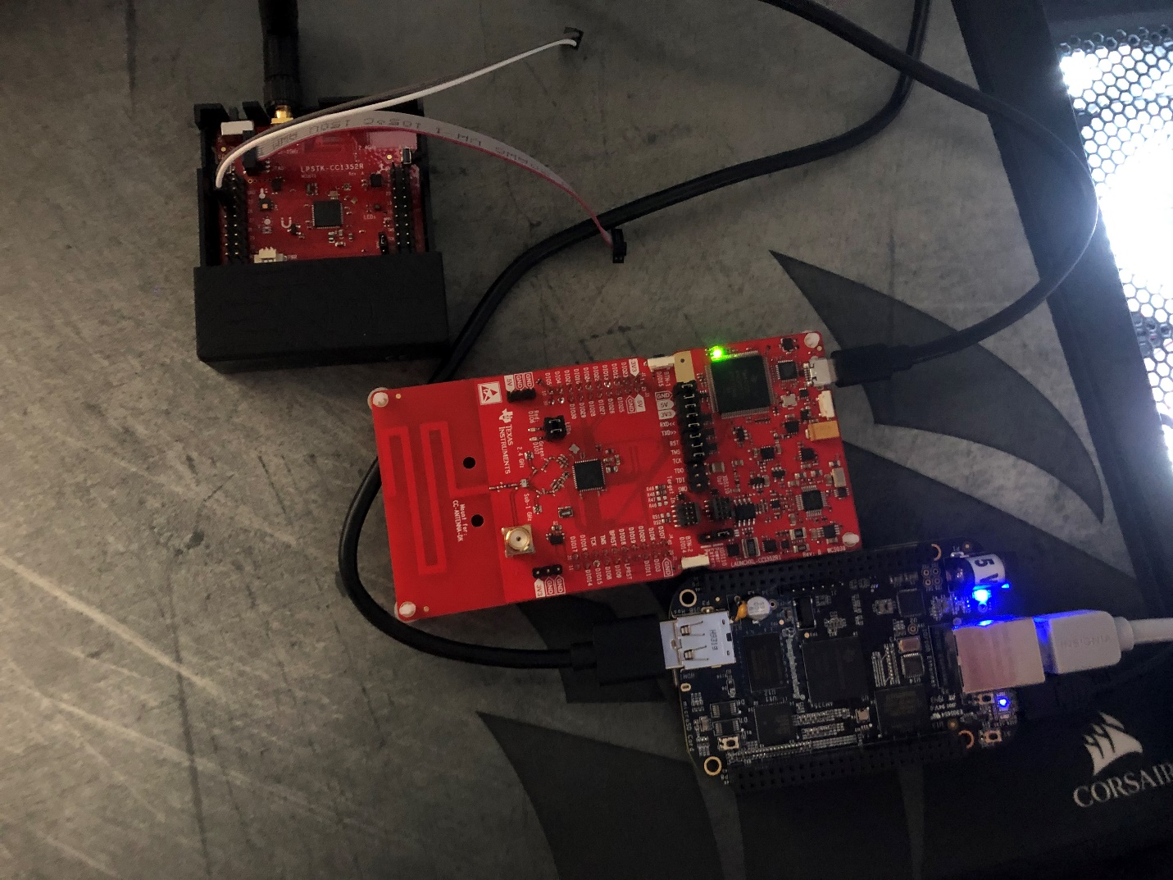

This is an image of the board setup

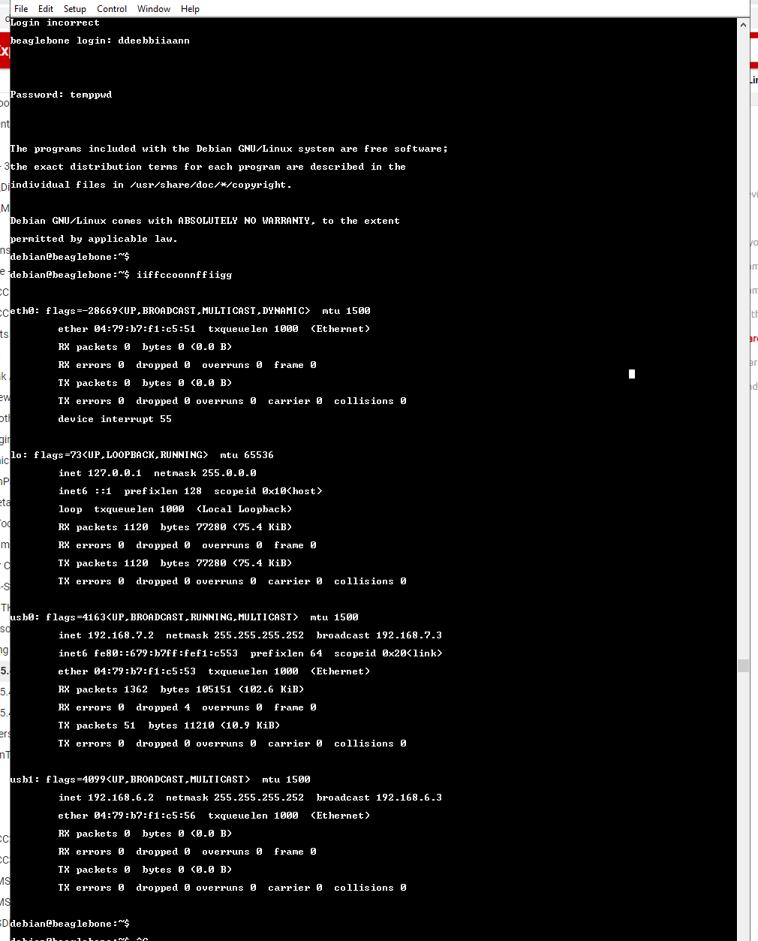

Login to ssh beaglebone

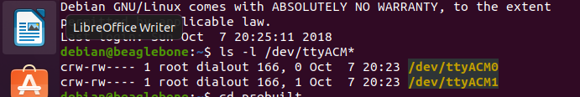

Checking for ttyACM 0 and 1



Succession for a reading

Video Demo:

https://www.youtube.com/watch?v=xDgviZoGh4I&feature=youtu.be